Day 13 - 28th June- 113195064 - Bondili Bhavya Charitha

TASK:1 –
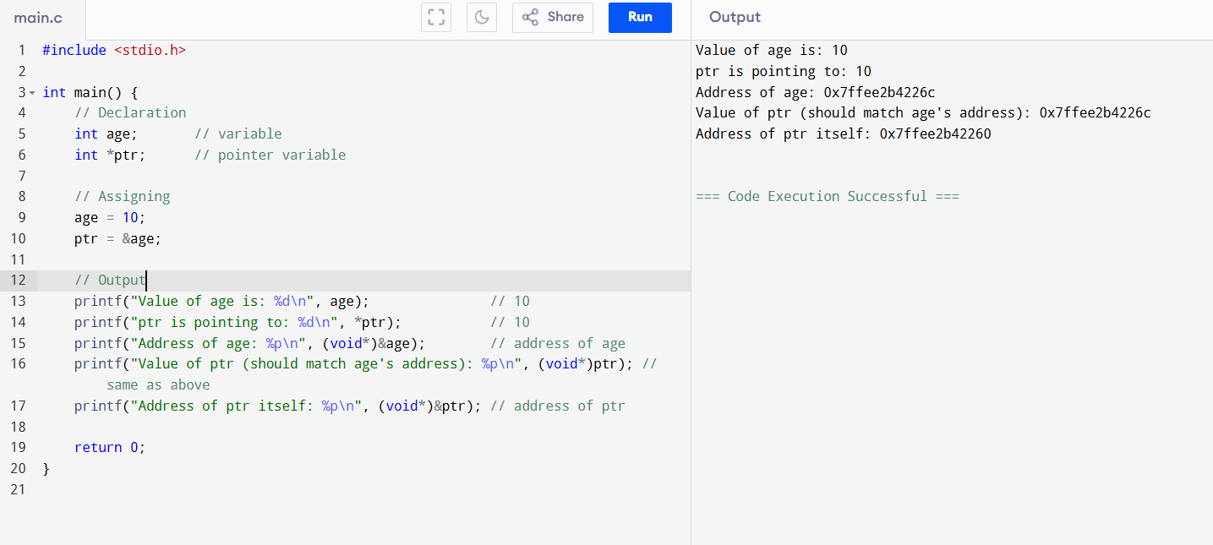
TASK:2 –
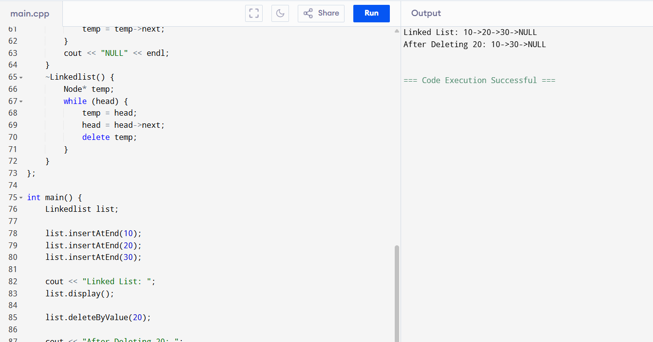

TASK:3 –
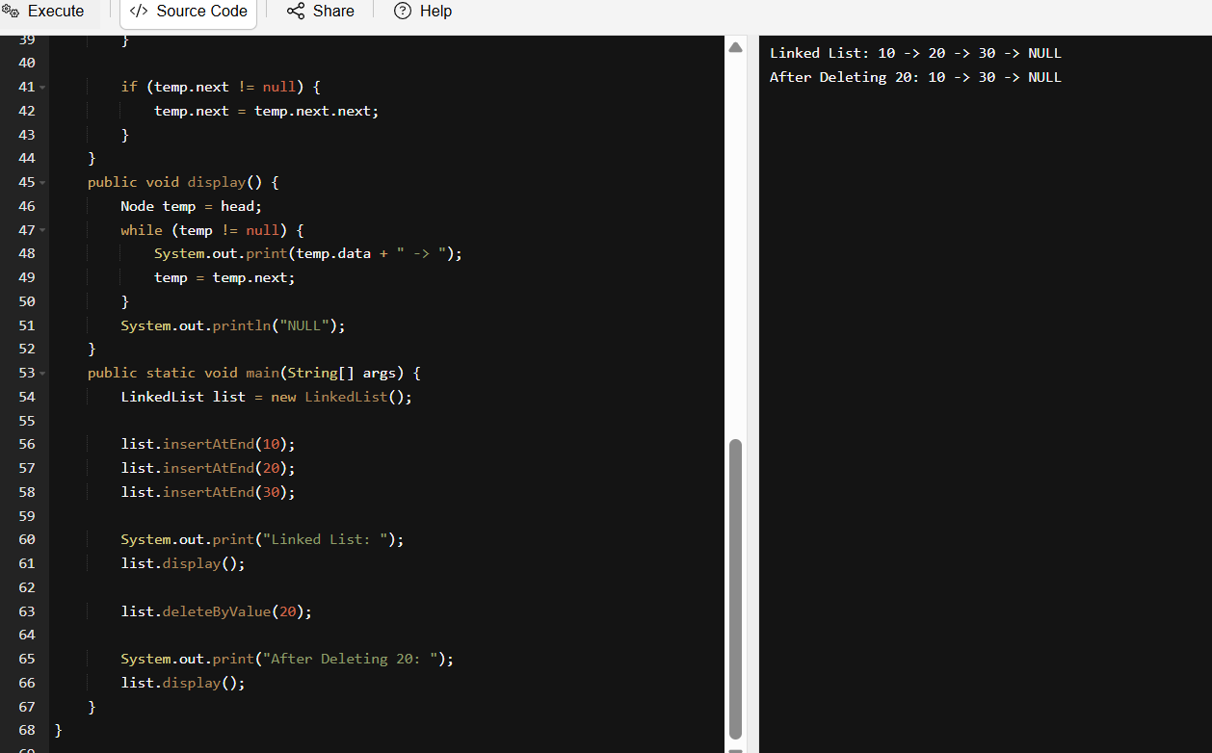
class Node {
int data;
Node next;

Node(int value) {
this.data = value;
this.next = null;
}
}
public class LinkedList {
private Node head;
public LinkedList() {
head = null;
}
public void insertAtEnd(int value) {
Node newNode = new Node(value);
if (head == null) {
head = newNode;
} else {
Node temp = head;
while (temp.next != null) {
temp = temp.next;
}
temp.next = newNode;
}
}
public void deleteByValue(int value) {
if (head == null) return;

if (head.data == value) {
head = head.next;
return;
}

Node temp = head;
while (temp.next != null && temp.next.data != value) {
temp = temp.next;
}

if (temp.next != null) {
temp.next = temp.next.next;
}
}
public void display() {
Node temp = head;
while (temp != null) {
System.out.print(temp.data + " -> ");
temp = temp.next;
}
System.out.println("NULL");
}
public static void main(String[] args) {
LinkedList list = new LinkedList();

list.insertAtEnd(10);
list.insertAtEnd(20);
list.insertAtEnd(30);

System.out.print("Linked List: ");
list.display();

list.deleteByValue(20);

System.out.print("After Deleting 20: ");
list.display();
}
}

TASK:4 –
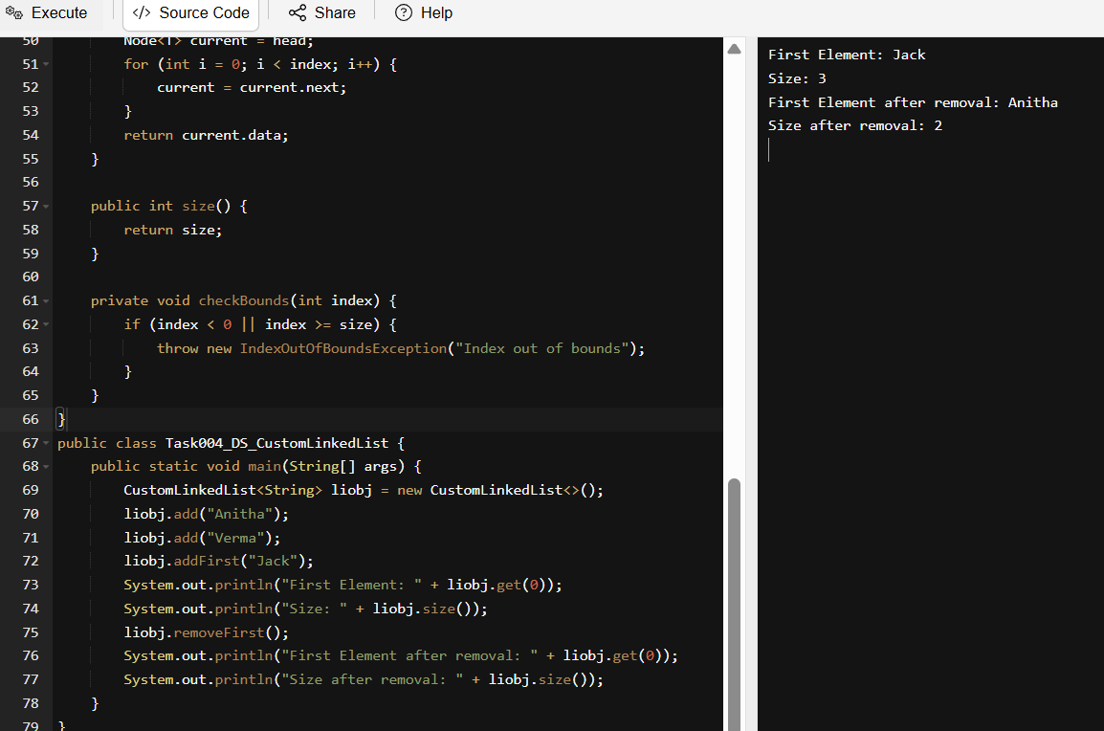
import java.util.NoSuchElementException;

class Node<T> {
T data;
Node<T> next;

public Node(T data) {
this.data = data;
this.next = null;
}
}

class CustomLinkedList<T> {
private Node<T> head;
private int size = 0;

public void add(T data) {
Node<T> newNode = new Node<>(data);
if (head == null) {
head = newNode;
} else {
Node<T> current = head;
while (current.next != null) {
current = current.next;
}
current.next = newNode;
}
size++;
}

public void addFirst(T data) {
Node<T> newNode = new Node<>(data);
newNode.next = head;
head = newNode;
size++;
}

public T removeFirst() {
if (head == null) {
throw new NoSuchElementException("List is empty");
}
T removedData = head.data;
head = head.next;
size--;
return removedData;
}

public T get(int index) {
checkBounds(index);
Node<T> current = head;
for (int i = 0; i < index; i++) {
current = current.next;
}
return current.data;
}

public int size() {
return size;
}

private void checkBounds(int index) {
if (index < 0 || index >= size) {
throw new IndexOutOfBoundsException("Index out of bounds");
}
}
}
public class Task004_DS_CustomLinkedList {
public static void main(String[] args) {
CustomLinkedList<String> liobj = new CustomLinkedList<>();
liobj.add("Anitha");
liobj.add("Verma");
liobj.addFirst("Jack");
System.out.println("First Element: " + liobj.get(0));
System.out.println("Size: " + liobj.size());
liobj.removeFirst();
System.out.println("First Element after removal: " + liobj.get(0));
System.out.println("Size after removal: " + liobj.size());
}
}
TASK:5 – List down all the methods of Linked list.
- add(E e): Adds an element to the end of the list.
- add(int index, E element): Inserts an element at a specific position.
- addFirst(E e): Inserts an element at the beginning.
- addLast(E e): Appends an element to the end.
- offer(E e): Adds an element to the end (queue-style).
- offerFirst(E e): Adds an element to the front.
- offerLast(E e): Adds an element to the end.

TASK:6 – Create linked list using Pre defined class and add elements to it also get 1st and last element.
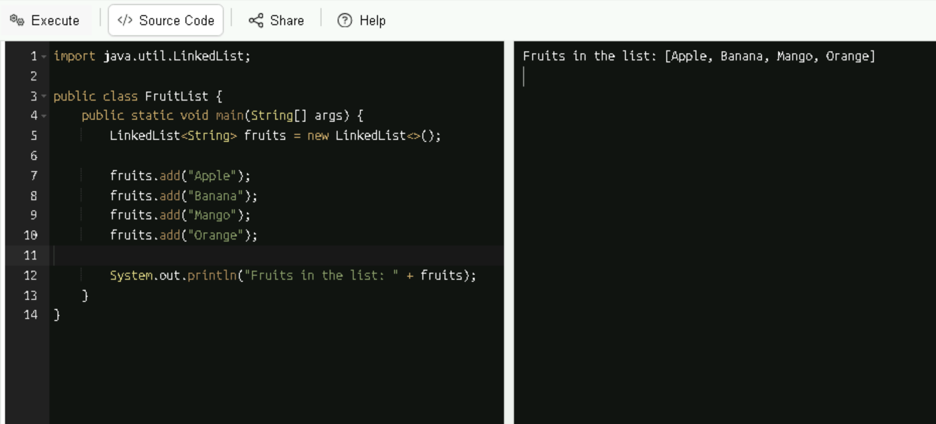
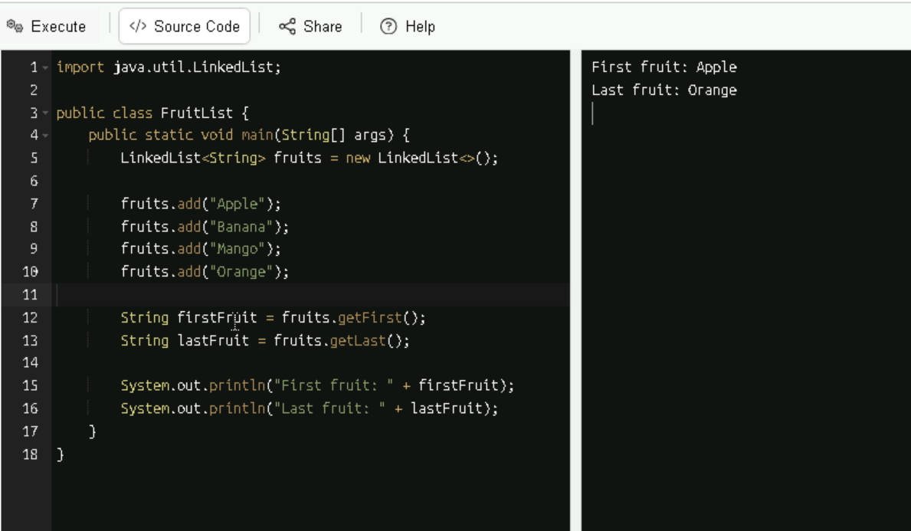

TASK:7 - Remove 1st element and last element and display all elements.
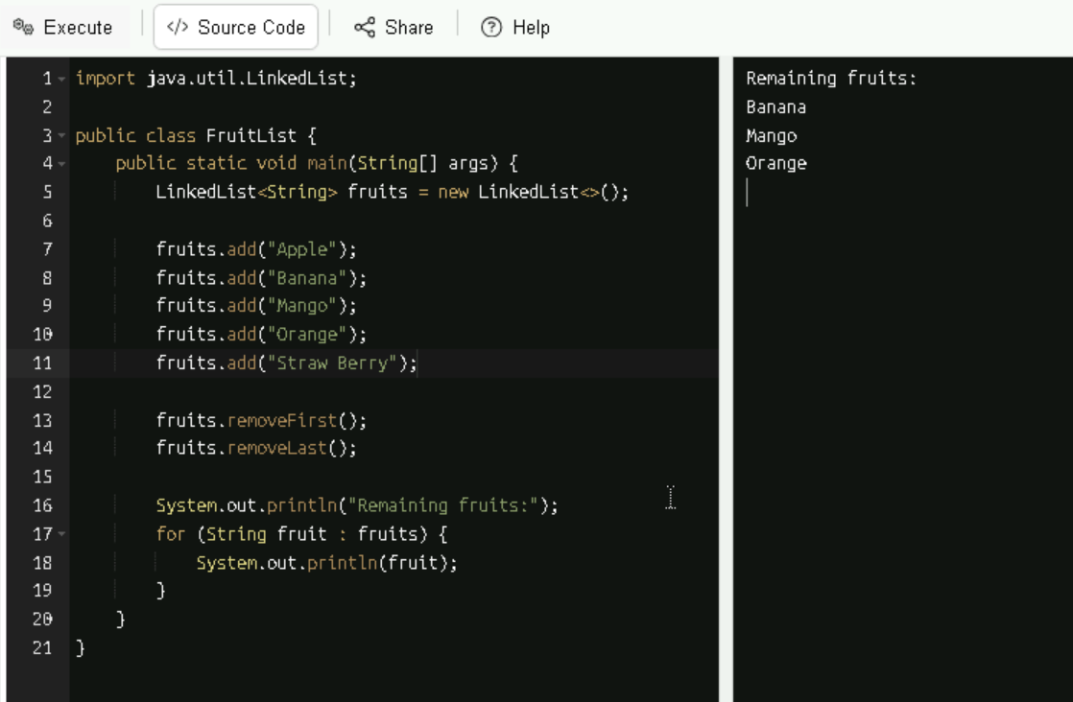

TASK:8 - in the list update the 1st element to a new value Hint: use set(1, "new value");
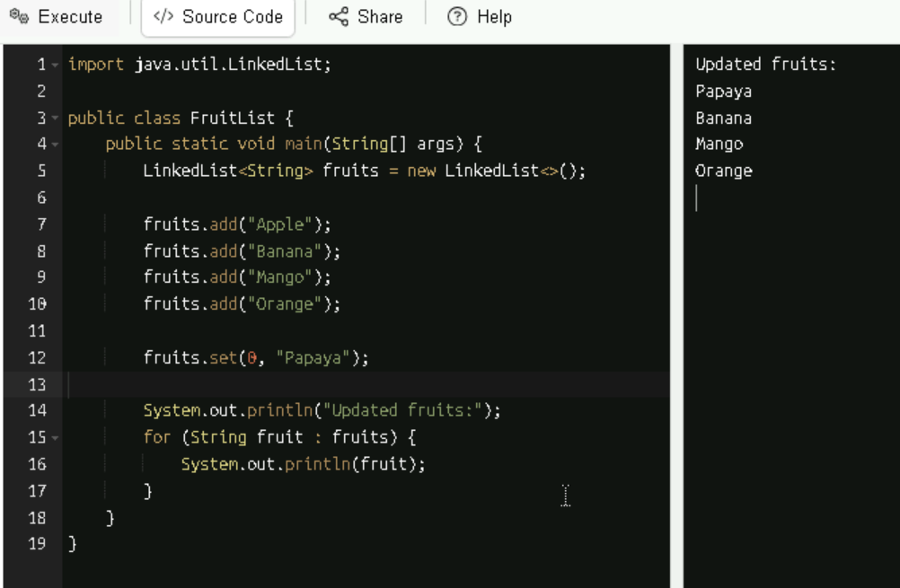

TASK:9 -
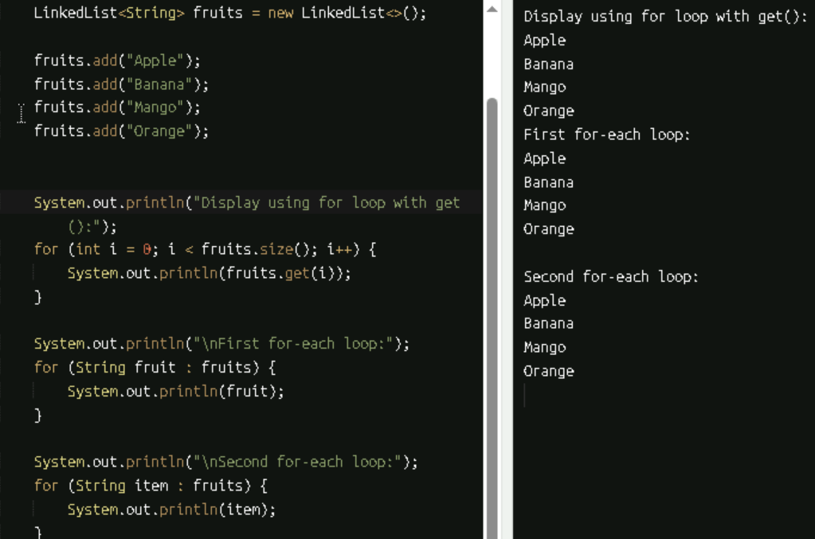

TASK:10 -
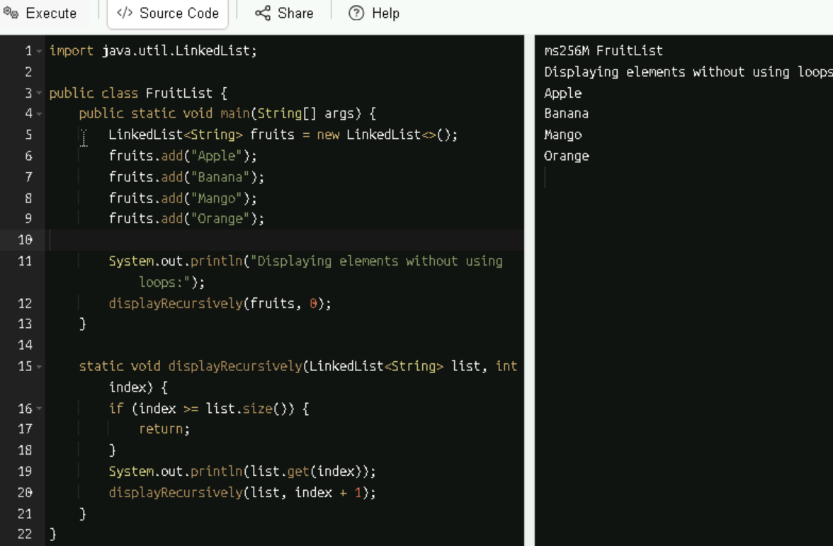
TASK:11 -
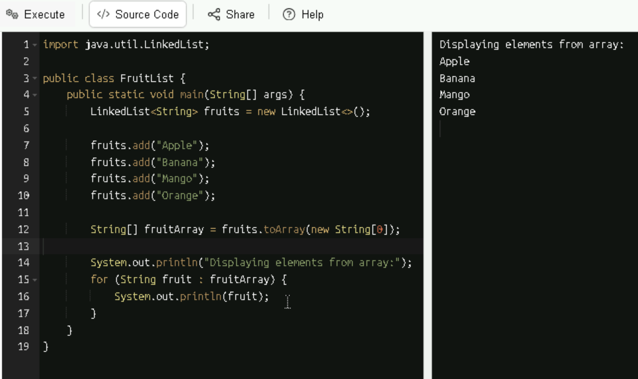
TASK:12 -
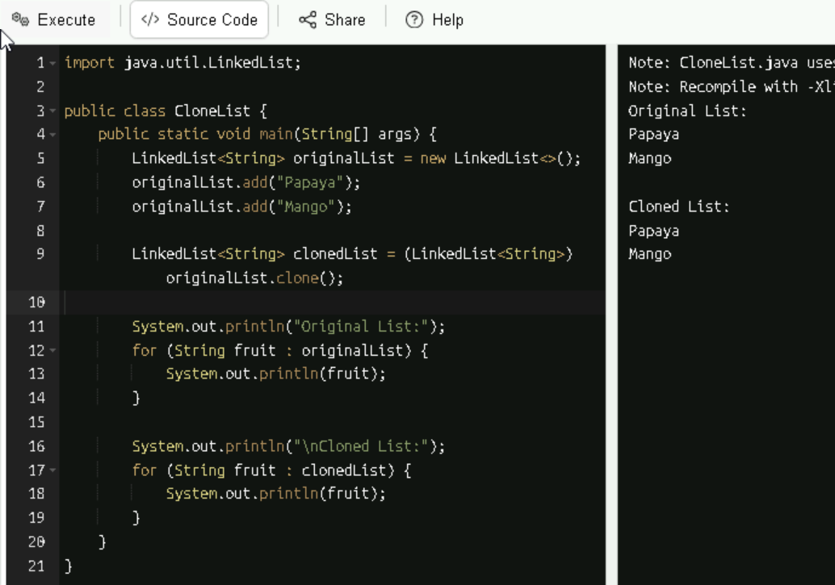

TASK:13 -
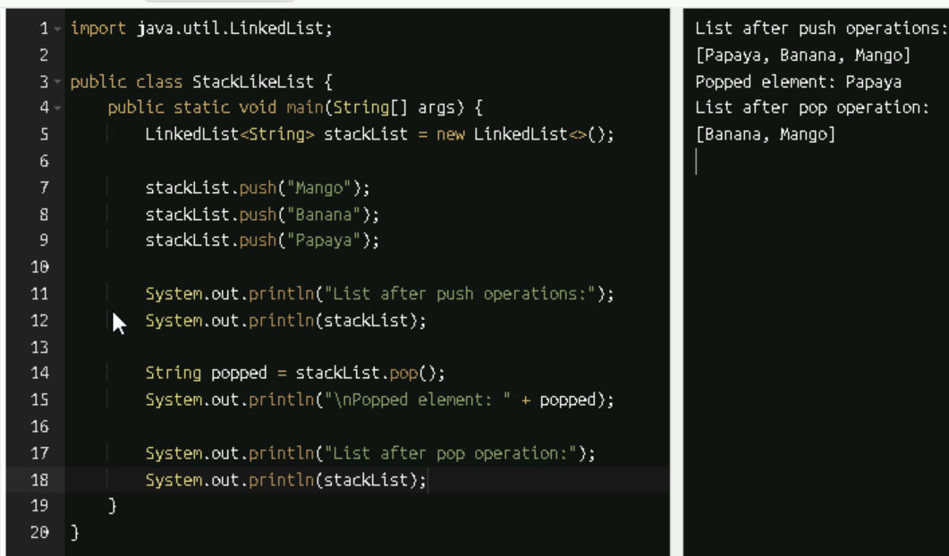
TASK:14 –
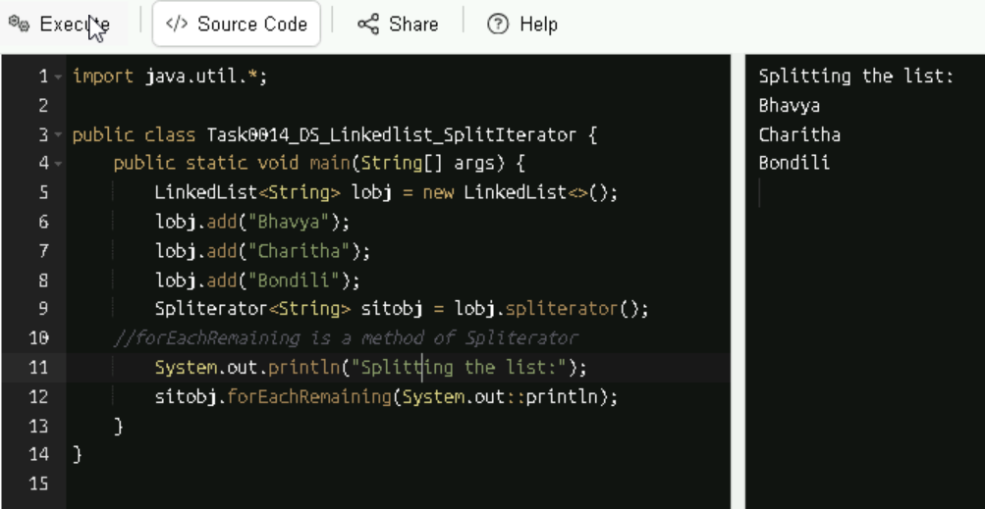

TASK:15 –
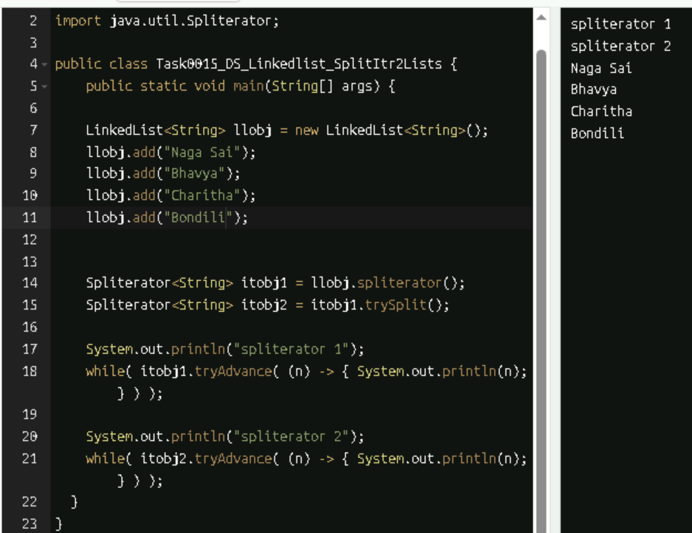

TASK:16 –
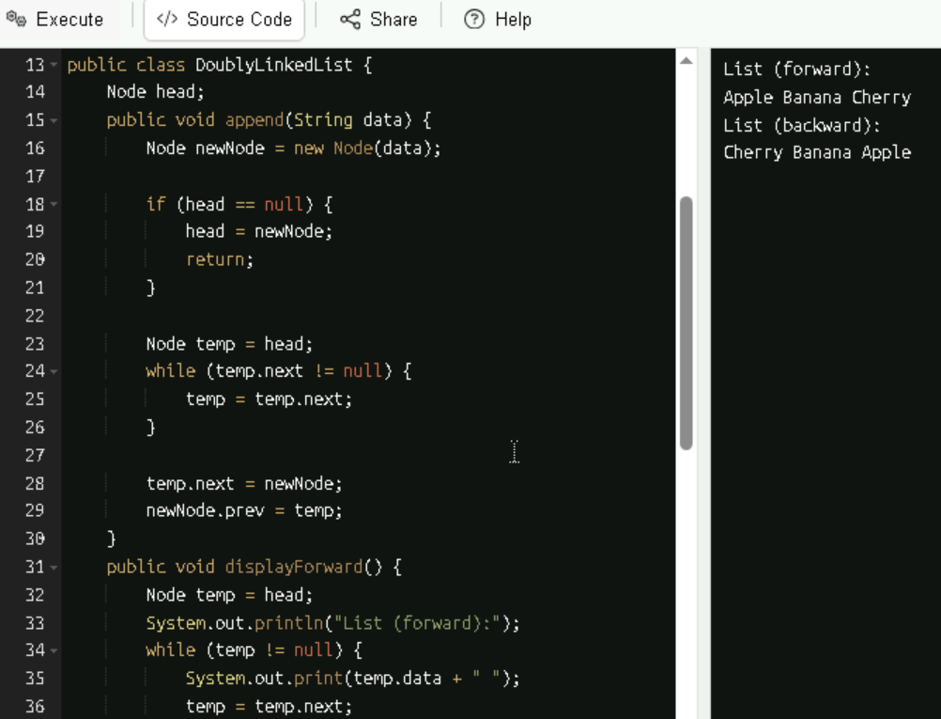

Split Iterator Worked
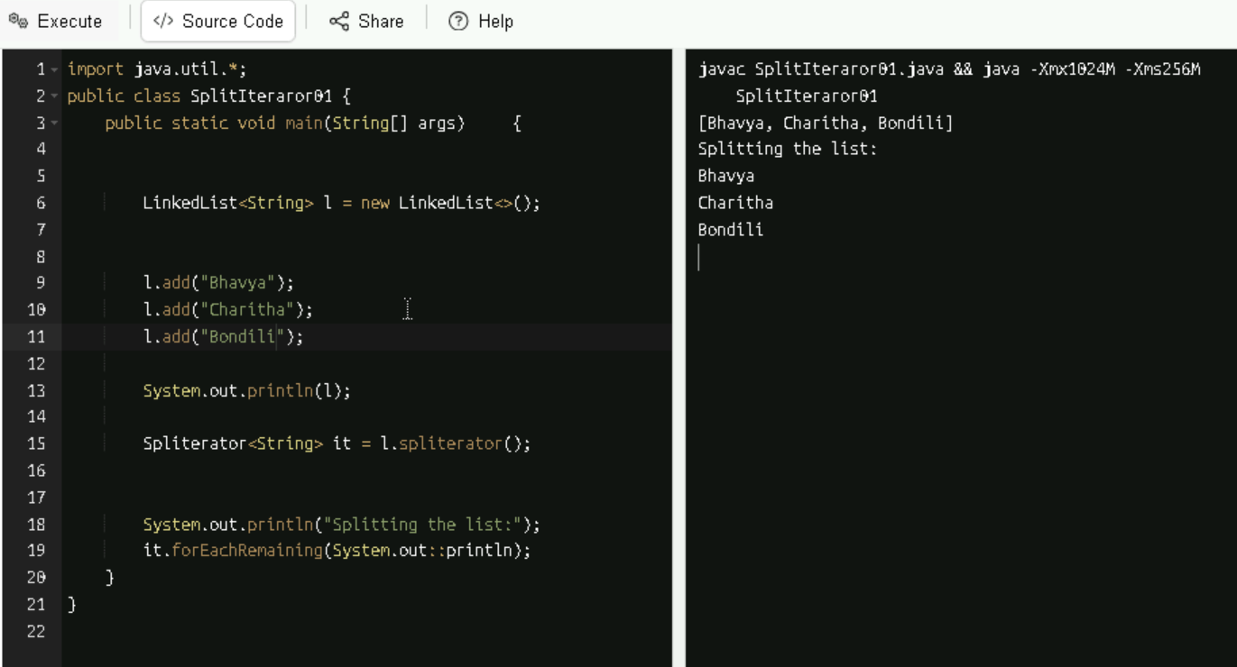
TASK:17 – Create a hashmap of capacity 10.
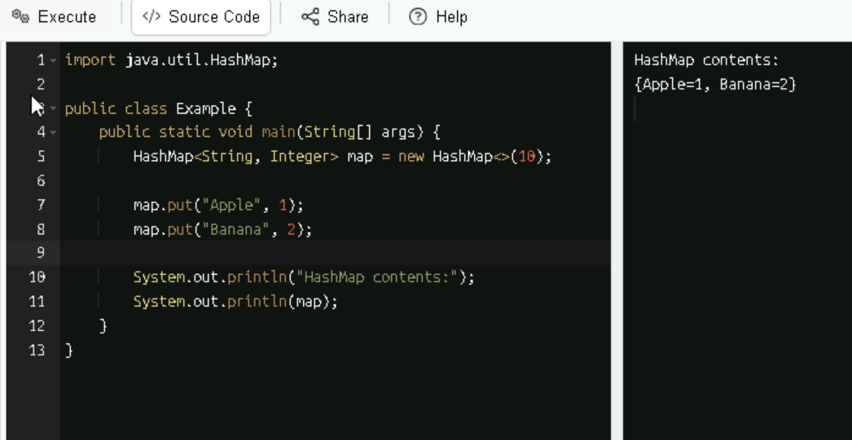

TASK:18 –
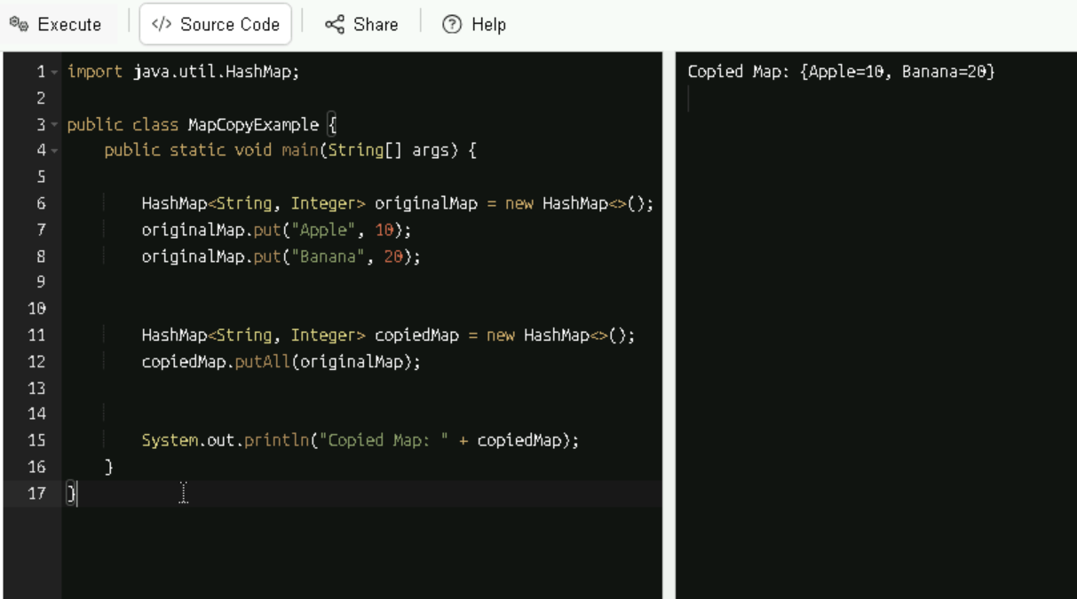
TASK:19 – Create a hashmap using loadfactor.
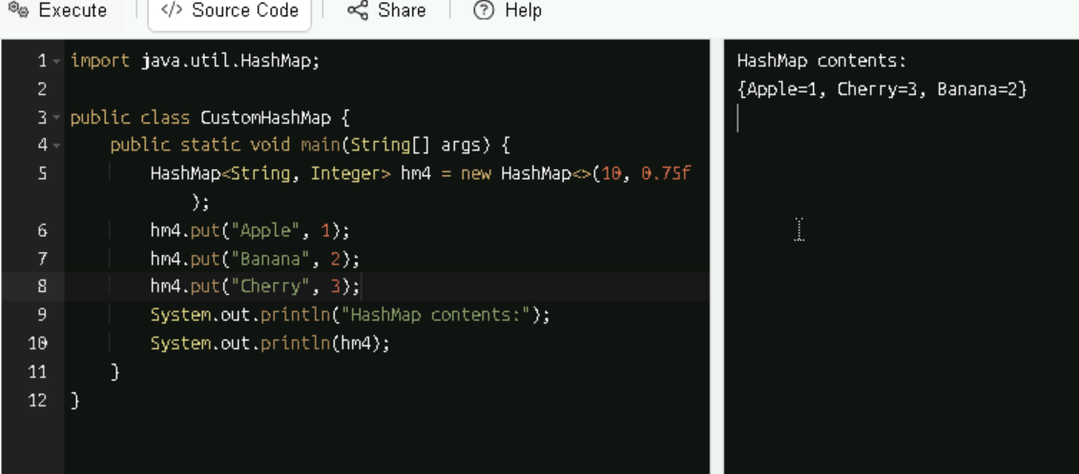

TASK:20 – Methods – Done
TASK:21 –
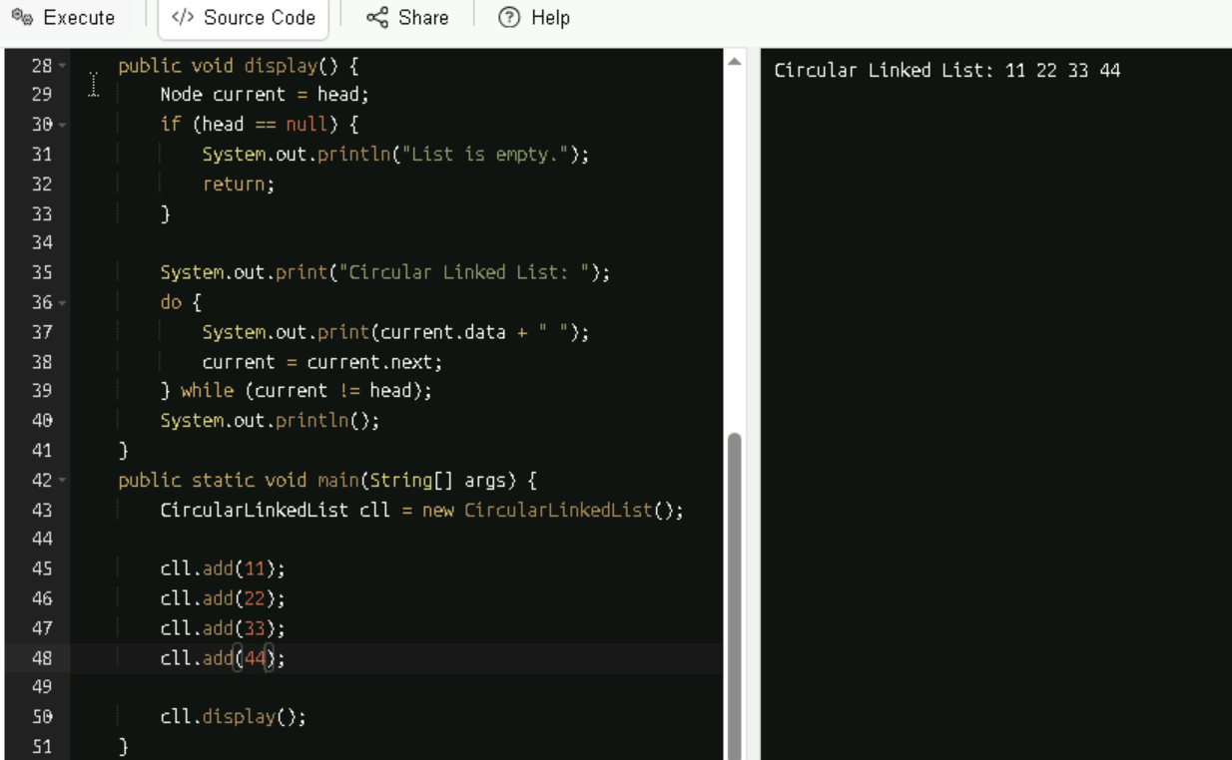
Home Work Task: Advantages of Linked List:
- It has a dynamic size unlike arrays, linked lists can grow or shrink at runtime without reallocation.
- It has efficient insertions/deletions as it does insert or delete elements (especially at the beginning or middle) is faster (no shifting required).
- It has no memory wastage as the memory is allocated only when needed, avoiding unused space like in arrays.
- It has a flexible data structure to forms the basis for stacks, queues, graphs, and more.
- It has an ease of implementation as it is useful for implementing complex data structures like hash tables and adjacency lists.
Dis-Advantages of Linked List:
- It has no random access as it will access an element takes O(n) time — you must traverse from the head.
- It has an extra memory for each node stores a pointer, increasing memory usage compared to arrays.
- It has cache unfriendliness as the nodes are scattered in memory, reducing CPU cache efficiency.
- It has more complexity as it is more complex to implement and debug than arrays.
- It has reverse traversal (Singly), In singly linked lists, you can’t go backward without extra logic or converting to a doubly linked list.
Home Work Task: Applications of Linked List
- Stacks and Queues: Linked lists are ideal for implementing dynamic stacks and queues.
- Graph Representations: These are used in adjacency lists to represent graphs efficiently.
- Dynamic Memory Allocation: OS uses linked lists to manage free memory blocks.
- Polynomial Arithmetic: Each term of a polynomial can be stored as a node.
- Music/Photo Playlists: Each image points to the next which is easy to add/remove items.
- Undo/Redo Functionality: Linked lists can track history in text editors or browsers.
- Hash Tables: These are used to handle collisions via chaining.
- Operating Systems: Process scheduling, memory management, and file systems often use linked lists.

